Tehničke karakteristike
Description | EM121 DI 8×24V DC
Physical Size
Dimensions(W×H×D) | 46×80×62mm
Power dissipation | 2W
Input Features
Number of integrated inputs | 8
Input type | Sink/Source(IEC Type 1 sink)
Input Voltage
Maximum continuous permissible | 30 VDC
Surge | 35 VDC, 0.5 s
Rated value | 24 VDC, 4 mA
Logic 1 signal(minimum) | 15 VDC, 2.5 mA
Logic 0 signal(maximum) | 5 VDC, 1mA
Isolation(Field Side to Logic Circuit)
Optical isolation(Galvanic) | 500 VAC, 1 minute
Isolation groups of | 4 points
Maximum input delay times | 4.5ms
Connection of 2 Wire Proximity Sensor(Bero)
Permissible leakage current | 1 mA, maximum
Cable Length
Unshielded(not HSC) | 300 m
Shielded | 500 m
Number of inputs ON Simultaneously
40℃ | 8
50℃ | 8
Power Consumption
From +5V DC(from I/O bus) | 40 mA

Dimenzije
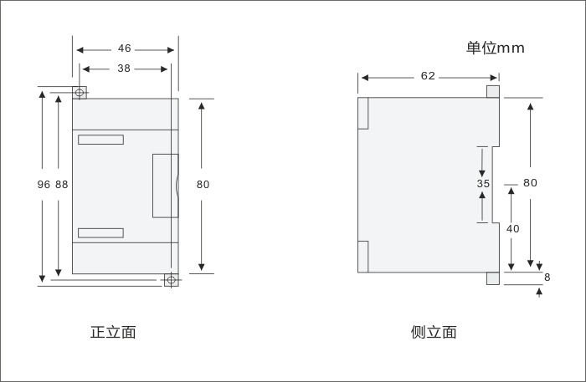

Šema spajanja
