Parametri
Description | EM122, 8DO×DC 24V
Physical Features
Dimensions(W×H×D) | 46×80×62mm
Power loss(dissipation) | 2W
From +5V (from I/O bus) | 50 mA
Output Features
Number of integrated outputs | 8 outputs
Output type | Solid State-MOSFET
Output voltage
Rated Value  Permissible Range  Logic 1 signal at maximum current  Logic 0 signal with 10 kohm load | 24V DC  20.4~28.8V DC  20V DC, minimum  0.1VDC, maximum
Output Current
Logic 1 signal  Number of output groups  Per group mounting (maximum)  Number of output ON (maximum)  Maximum current per group  Lamp load  Contact resistance  Leakage current per point  Surge current | 0.5A  2  4  8  2A  5W  0.3 ohm  10μA, maximum  8A，100ms
Isolation | 500V AC for 1 minute
In group of | 4 points
Output Delay
Off to On  On to Off | 50 μs, maximum  200 μs, maximum
Cable Length
Unshielded | 150 m
Shielded | 500 m
Dimenzije
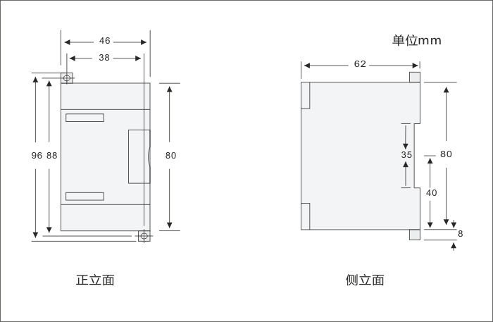

Šema povezivanja
