Tehničke Karakteristike
Description | EM122, 8DO×RELAY
Physical Features
Dimensions (W×H×D) | 46×80×62mm
Power loss (dissipation) | 2W
Output Features
Number of integrated outputs | 8
Output type | Relay, dry contact
Output Voltage | DC：5～30V，AC：5～250V
Output Current
Logic 1 signal  Number of output groups  Per group mounting (maximum)  Number of output ON (maximum)  Maximum current per group  Lamp load  Contact resistance  Surge current  Overload protection | 2A  2  4  8  8A  5W  0.2 ohm  8A for 100ms, maximum  No
Isolation
In group of  Isolation coil to contact  Isolation between open contacts  Isolation resistance | 4 points  1500 VAC for 1minute  750 V AC for 1 minute  100M ohm, minimum when new
Relay Features
Switch delay  Switch Frequency  Lifetime mechanical (no load)  Lifetime contacts at rated load | 15ms, maximum  1HZ  5,000,000 open/close cycles  300,000
Cable Length
Unshielded | 150 m
Shielded | 500 m
Power Consumption
From +5V(from I/O bus)  From L+  L+ coil power voltage range | 56 mA  9 mA per output when ON  20.4 to 28.8 VDC
Dimenzije
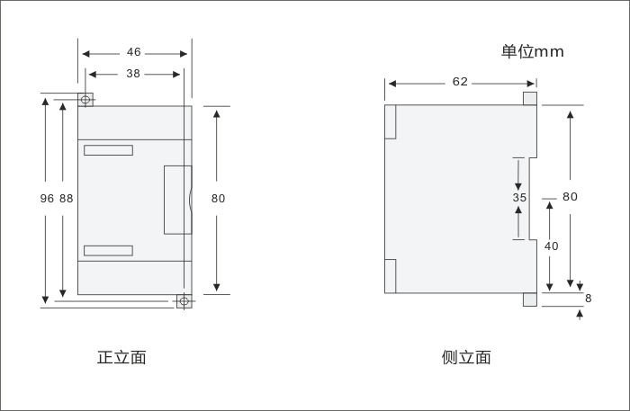

Šema Povezivanja
