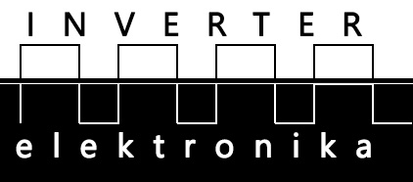

Tehničke Karakteristike
Features | 4 Inputs/4 Outputs  24V DC
Order No. | CTS7 123-1BF10
Physical Features
Dimension(W*H*D) | 46×80×62mm
Power Consumption | 2W
Input Features
Number of Inputs | 4
Input Type | Sink/Source
Input Voltage
Rated Voltage | 24V DC
The Maximum permissible Voltage | 30V DC
Surge Voltage | 35V DC， 0.5 second
Signal "1" | 15～30V
Signal "0" | 0～5V
Isolation
Optical Isolation | 500V AC， Duration: within 1 minute
Number of Isolation points per group | 4
The longest Input Delay | 4.5 millisecond
Sink Current | Max: 1mA AC
Length of Cable
Unshielded | 300 m
Shielded | 500 m
Simultaneous Inputs
40℃ | 4
50℃ | 4
Output Features
Number of Outputs | 4
Type of Output | Solid－MOSFET
Output Voltage
Rated Load Voltage  Range of Voltage(Permissible)  Signal "1"  Signal "0" | 24V DC  20.4～28.8V DC  Minimum: 20V DC  Maximum: 0.1V DC（10K ohm load）
Output Current
Signal "1"  Number of Output Groups  Number of Outputs per group  Simultaneous Outputs  Maximum Current per group  Lamp Load  Contact Resistance  Peak Current per point  Surge Current（Max） | 0.5A  1  4  4  2A  5W  0.3 Ω  10 microamp  8A，100 millisecond
Isolation | Optically coupled isolation，500V AC，duration: within 1 minute
Number of Isolation Points Per group | 4
Output Delay
Off to On  On to Off | Max: 50 microsecond  Max: 200 microsecond
Length of Cable
Unshielded | 150 m
Shielded | 500 m
+5V DC Consumption Current | 54 mA

Dimenzije
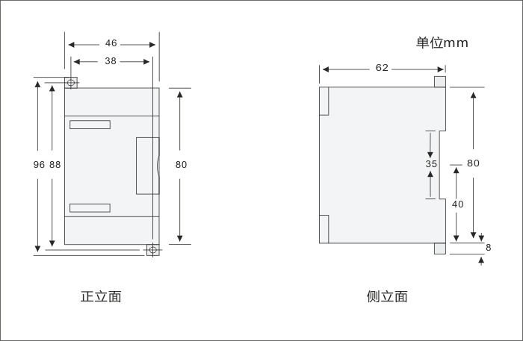

Šema Povezivanja
