Tehničke Karakteristike
Features | 4DI×24V DC  4DO×Relay
Order No. | CTS7 123-1HF10
Physical Features
Dimension(W*H*D) | 46×80×62mm
Power Consumption | 2W
Input Features
Number of Inputs | 4
Type of Input | Sink/Source
Input Voltage
Rated Voltage | 24V DC
Maximum Permissible Voltage | 30V DC
Surge Voltage | 35V DC， 0.5 second
Signal "1" | 18～30V
Signal"0" | 0～5V
Isolation
Optical Isolation | 500V AC，duration: within 1 minute
Number of Isolation points per group | 4
The longest Input Delay | 4.5 millisecond
Sink Current | Maximum: 1mA AC
Length of Cable
Unshielded | 300 m
Shielded | 500 m
Simultaneous Inputs
40℃ | 4
50℃ | 4
Output Features
Number of Outputs | 4
Type of Output | Relay－dry contact
Range of Output Voltage | DC: 5~30V, AC: 5~250V
Output Current
Signal "1"  Output Groups  Number of Outputs per group  Simultaneous Outputs  Maximum Current of a group  Lamp Load  Contact Resistance  Surge Current（Max）  Short-Circuit Protection | 2A  1  4  4  8A  DC:30W,AC:200W  0.2 Ω  7A，contact closed  External
Isolation
Number of Isolation Points per Group  Coil to logic power  coil to contact  Resistance(coil to contact) | 4  -  1500V AC, last for 1 minute  Minimum:100MΩ
Relay Features
Switching Delay  Switching Frequency（Max）  Mechanical life cycle(Zero Load)  Contact Endurance(Rated Load) | 15 millisecond  1HZ  10.000.000  100.000
Length of Cable
Unshielded | 150 m
Shielded | 500 m
Power Consumption
+5V DC Consumption Current | 49 mA
L+ | When put through,9 mA per output
Coil Voltage Range of L+ | 20.4－28.8V DC

Dimenzije
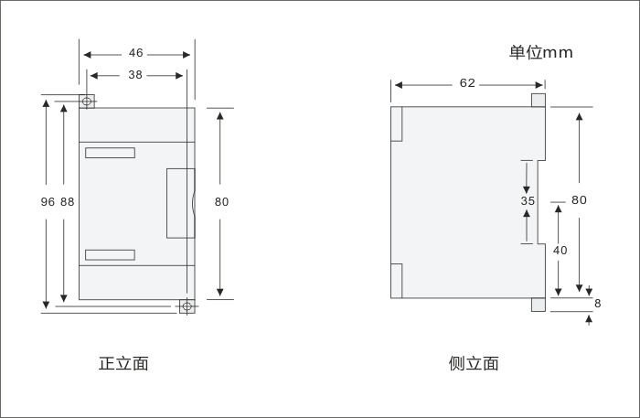

Šema Spajanja
