Dimenzije
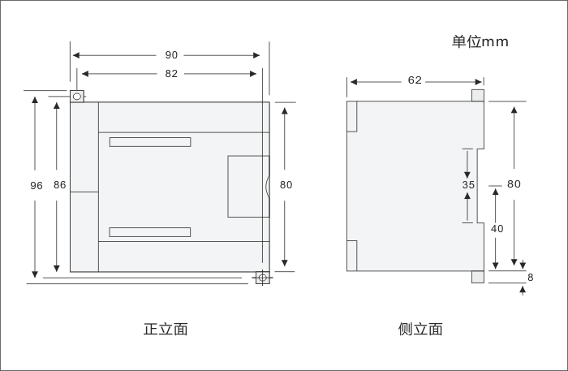

Šema povezivanja
1.CTS7 112-1AD20-0X14
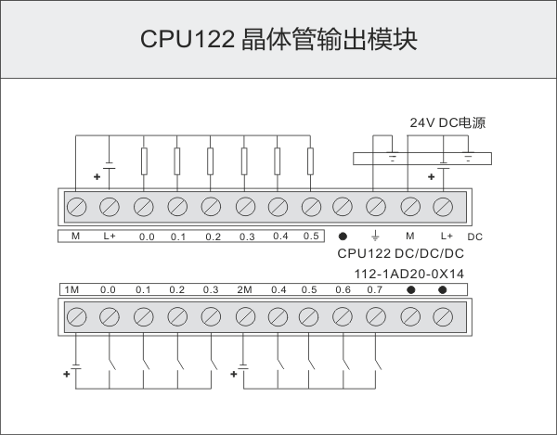

2.CTS7 112-1BD20-0X14
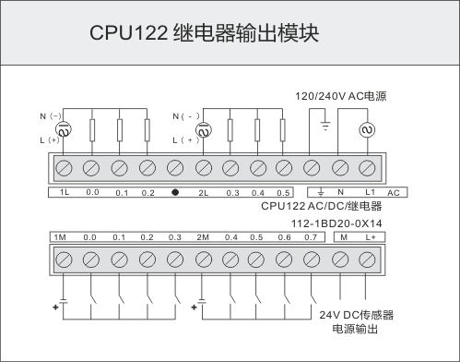
Komunikacioni port pinout
Konektor | PIN | PORT0(RS485)
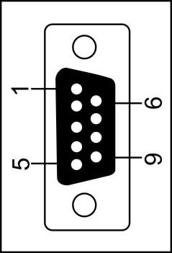 | 1 | Shell grounded
 | 2 | Logical
 | 3 | RS-485 Signal B
 | 4 | RTS(TTL)
 | 5 | Logical
 | 6 | +5V，100Ω resistances in series
 | 7 | +24V
 | 8 | RS-485 Signal A
 | 9 | /
 | Shell | Shell grounded

Performance Parameters
Physical Features
Dimension(W×H×D) | 90×80×62mm
Power Dissipation | 5W
Memory Features
Program Memory | 6KB，4K for common users，2K for encrypted users
Data Memory | 2KB
Power-failure retention power | button battery
General Features
Timers in total  1ms  10ms  100ms | 128（T0-T127）  4  16  108
Counters in total | 128(button battery)
Internal Memory Bits | 128(button battery)
Power-failure retention of internal memory | 112
Time interrupts | 2×1ms Resolution
Edge interrupts | 4 rising edges/ falling edges
Boolean execution speed | 0.5µs
Float execution speed | 16µs
Runtime clock | √
Integrated Communication Function
Communication Port | PORT0：RS485
PPI Baud Rate | 9.6, 19.2kbps
Maximum cable length per segment  Isolated repeater applied  Isolated repeater unapplied | When it is 1200 m, 38.4k.  50 m
Maximum number of stations | 4 stations per segment,32 stations per network
Maximum number of masters | 16
Point to point (PPI Mater Mode) | ×
Power Function
Input Voltage | 20.4 to 28.8 VDC ， with anti- reverse connection protection
+5V power for the extended bus | ×
24 VDC Sensor Power supply | ×
I/O Features
Number of integrated Digital inputs | 8
Input type | Sink/Source
Number of integrated Digital outputs | 6
Output type | Solid-MOSFET(Source)
Digital I/O mapping area | 128(64 inputs/64 outputs)
Analog I/O mapping area | 32(16 inputs/16 outputs)
Maximum number of expandable I/O modules | 0
Maximum number of digital I/O | 14
Maximum number of analog I/O | 0
Pulse catch inputs | 8
High-speed counters  Single phase counters | 4×50KHz，support HSC0、HSC3、HSC4、HSC5，do not support HSC1and HSC2
Digital Input Features
Number of integrated digital input | 8
Input type | Sink/Source
Rated voltage | 24V DC
Maximum continuous permissible voltage | 30V DC
Logical 1 Signal (minimum)  Logical 0 Signal (Maximum ) | 14 VDC，2.5mA  5 VDC，1mA
Isolation( field side and logical circuit)  Optical isolation(Galvanic)  Isolation group | √  500V AC，1 minute  refer to the Terminal Identification
Simultaneous Inputs | 8
Maximum cable length  Shielded  Unshielded | 500 m(standard input)、50m(high-speed counter input)  300 m( standard input)
Digital Output Features
Number of integrated digital output | 6
Output type | Solid-MOSFET(Source)
Maximum rated current of each output  Surge Current | 0.75A  8A，100 millisecond
Lamp load(Max) | 5W
On- state resistance | 0.3 ohm , (Max :0.6 ohm )
High-speed pulse output | 2×50KHz，Q0.0 and Q0.1， directionless output; Support MC_PTP_R/MC_SPEED_CTRL etc. of CPU, do not support PTO/PWM of programming software
Simultaneous output | 6
Two parallel outputs | only when the two outputs are in the same group
Maximum cable length  Shielded  Unshielded | 500m(standard output)  150m(standard output)
Performance Parameters
Physical Features
Dimension(W×H×D) | 90×80×62mm
Power dissipation | 7W
Memory Features
Program memory | 6KB，4K for common users，2K for encrypted users
Data memory | 2KB
Power-failure retention power | button battery
General Features
Timers in total  1ms  10ms  100ms | 128（T0-T127）  4  16  108
Counters in Total | 128(button battery)
Internal memory bit | 128( button battery)
Power-failure retention of internal memory | 112
Time interrupts | 2×1ms resolution
Edge interrupts | 4 rising edges/ falling edges
Boolean execution speed | 0.5µs
Float execution speed | 16µs
Runtime clock | √
Integrated Communication Function
Communication port | PORT0：RS485
PPI Baud Rate | 9.6, 19.2kbps
Maximum cable length per segment  Isolated repeater applied  Isolated repeater unapplied | When it is 1200 m, 38.4k.  50m
Maximum number of stations | 4 stations per segment,32 stations per network
Maximum number of masters | 16
Point to point (PPI Mater Mode) | ×
Power Function
Input Voltage | 85-264VAC(47-63HZ)
+5V power for the extended bus | ×
24 VDC Sensor Power supply | 240 mA
I/O Features
Number of integrated Digital inputs | 8
Input type | Sink/Source
Number of integrated Digital outputs | 6
Output type | Relay, dry contact
Digital I/O mapping area | 128(64 inputs/64 outputs)
Analog I/O mapping area | 32(16 inputs/16 outputs)
Maximum number of expandable I/O modules | 0
Maximum number of digital I/O | 14
Maximum number of analog I/O | 0
Pulse Catch inputs | 8
High-speed counters  Single phase counters | 4×50KHz，support HSC0、HSC3、HSC4、HSC5, do not support HSC1 and HSC2
Digital Input Features
Number of integrated digital input | 8
Input type | Sink/Source
Rated voltage | 24V DC
Maximum continuous permissible voltage | 30V DC
Logical 1 Signal (minimum)  Logical 0 Signal (Maximum ) | 14 VDC，2.5mA  5 VDC，1mA
Isolation( field side and logical circuit)  Optical isolation(Galvanic)  Isolation group | √  500V AC，1 minute  refer to the Terminal Identification
Simultaneous Inputs | 8
Maximum cable length  Shielded  Unshielded | 500 m(standard input)、50m(high-speed counter input)  300 m( standard input)
Digital Output Features
Number of integrated digital output | 6
Output type | Relay, dry contact
Maximum rated current of each output  Surge Current | 2A  5A，4S@10% duty ratio
Lamp load(Max) | 30 WDC/200WAC
On- state resistance | 0.2 ohm
Simultaneous output | 6
Two parallel outputs | ×
Maximum cable length  Shielded  Unshielded | 500m(standard output)  150m(standard output)

